**INDIA AGRICULTURAL CROP PRODUCTION ANALYSIS ( 1197-2021 )**

# **Indian Agriculture – an introduction**

Agriculture has been the backbone of the Indian economy and it will continue to

remain so for a long time. It has to support almost 17 per cent of world population

from 2.3 per cent of world geographical area and 4.2 per cent of world’s water

resources. The economic reforms, initiated in the country during the early 1990s,

have put the economy on a higher growth trajectory. Annual growth rate in GDP has

accelerated from below 6 percent during the initial years of reforms to more than 8

percent in recent years. This happened mainly due to rapid growth in non-agriculture

sector. The workforce engaged in agriculture between 1980-81 and 2006-07

witnessed a very small decline; from 60.5 percent to 52 percent.

The present cropping intensity of 137 per cent has registered an increase of only 26

per cent since 1950-51. The net sown area is 142 Mha. The net irrigated area was

58.87 Mha in 2004-05. Presently, the total net irrigated area covers 45.5 per cent of

the net sown area, the remaining 54.5 per cent is rainfed. The degradation of land and

surface as well as ground water resources results in fast deterioration of soil health.

Losses due to biotic (insect-pests, diseases, weeds) and abiotic (drought, salinity, heat,

cold, etc.) stresses account for about one-fourth of the value of agricultural produce.

The storage, transportation, processing, value addition and marketing of farm produce

need to be improved to enhance household food, nutrition and livelihood security.

Indian agriculture is characterized by agro-ecological diversities in soil, rainfall,

temperature, and cropping system. Besides favourable solar energy, the country

receives about 3 trillion m3 of rainwater, 14 major, 44 medium and 55 minor rivers

share about 83 per cent of the drainage basin. About 210 billion m3 water is estimated

to be available as ground water. Irrigation water is becoming a scarce commodity.

Average size of farm holdings gradually reduced from 2.58 ha to 1.57 ha (Table 1).

Small and marginal farmers have limited resources especially in rain-fed regions

where only animate power is used resulting in low productivity. Though agricultural

production is high, the per hectare productivity is much lower than world average.

There is an urgent need to increase productivity.

Smaller the farm, greater is the need for marketable surplus, so that small farmers can

have a reasonable income. Achieving this goal will be possible only if we develop

and disseminate eco-technologies rooted in the principles of ecology, economics,

gender equity and employment generation. This is the pathway to an “ever-green

revolution” in agriculture. The estimated food requirement in India and total

production of major crops indicate that to keep pace with the present population

growth and consumption pattern, food grain requirement has been estimated to be 240

MT by 2020 and 300 MT by 2025. Annual agricultural growth should be maintained

at 6.7 per cent to meet these demand projections.

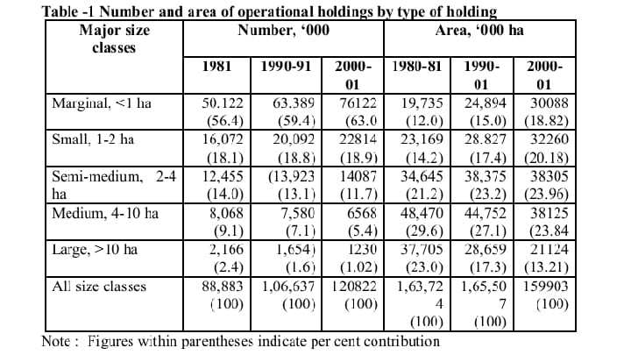

# **DATA COLLECTION**

**Agricultural Production and Productivity**

The nation is striving to find ways and means to keep its burgeoning population

adequately fed. On the one hand it is facing the problem of declining productivity and

on the other, challenges posed by liberalization. In such a scenario, leveraging the

available natural resources and existing infrastructure is the only way to make the

ends meet. Management of the already built infrastructure in harmony with natural

systems is the clarion call of the day. Knowledge of the extent of existing

infrastructure and natural resources is one of the most basic pre-requisites to utilize

them effectively and in a sustainable manner.

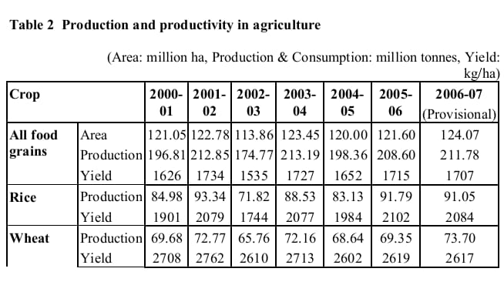

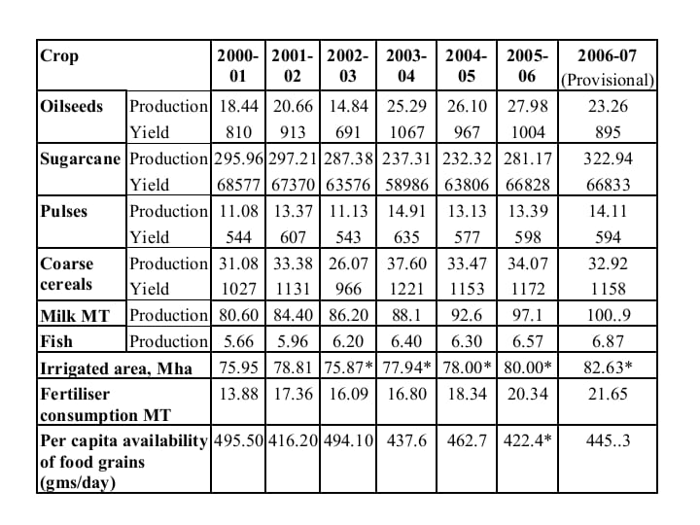

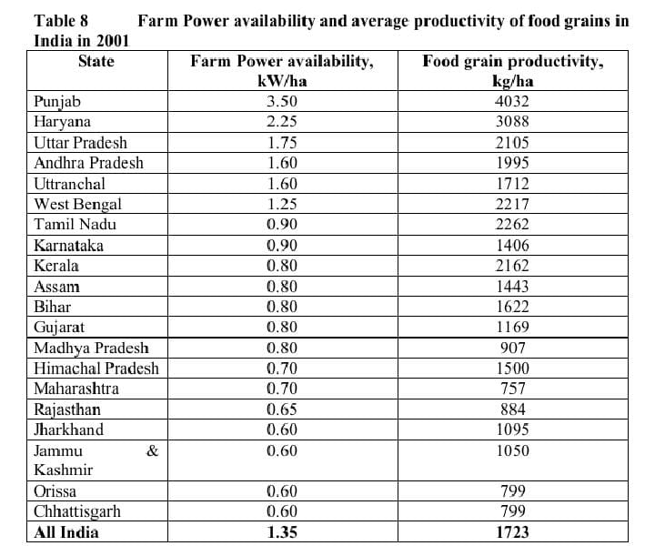

**Farm Power Availability**

India has made remarkable progress in agricultural mechanization technology. The

country evolved a selective mechanization model using a power mix based on animate

and inanimate power sources. The mix of power sources includes human beings,

animals, power tillers, tractors, engines and electric motors. One of the globally used

Index of Agriculture Mechanization (IAM) is power availability per unit area. The

power availability is computed by taking both animals and inanimate power sources.

**Post Harvest Technology Research and Development**

Post harvest technology is commodity and location specific. However, the present

requirement is to develop need-based and market driven PHT and equipment for loss

prevention and value addition to raw food materials of plant, animal and aquatic

origin for internal and international markets. Diversification in the present uses of

rainfed and other crops may be considered . The technology so developed

must lead to rural industrialization, thereby creating employment and income

generation opportunities. Appropriate PHT would help in enhancing per capita food

and fibre availability from the limited and dwindling land and water resources.

**PRESENT USE AND SUGGESTED DIVERSIFICATION OF FIELD CROPS OF**

**BETTER DOMESTIC UTILIZATION AND EXPORT PROMOTION**

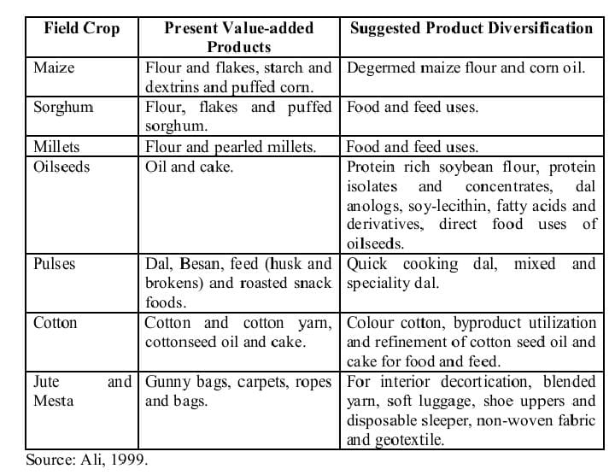

# **DATA PREPARATION**

Globally about 65 per cent of the green house gases are produced by the industry and

35 per cent is contributed by agriculture and related activities. Agriculture, however,

acts both as a source and sink for the green house gases. Indian agriculture is

contributing 2.4 per cent of the methane and 1.5 per cent of the nitrous oxide of the

total world production. Impact on productivity is a net result of contrasting effects of

higher concentration of carbon dioxide and other gases as well as temperature.

Overall productivity of rice and wheat in northern India is growing to be reduced by

2070. Similarly it will be true for wheat yields in central India.

In situ management of residues instead of burning, fuel saving zero tillage, water and

fertilizer management in rice, drainage of waterlogged soils, preservation of wetlands

will certainly cut down production of greenhouse gases. Now a days, there is a

greater concern on nitrous oxide emissions because of its very long atmospheric half-

life requiring special infrastructure and human resources. Sequestration of green

house gases through forestry, agro-forestry, horticultural and other plantations will

become a reality especially when the Kyoto Protocol becomes binding mechanism.

India is progressing rapidly noting its position in World Agriculture

ranking 1-3 in most of crop/horticultural items.

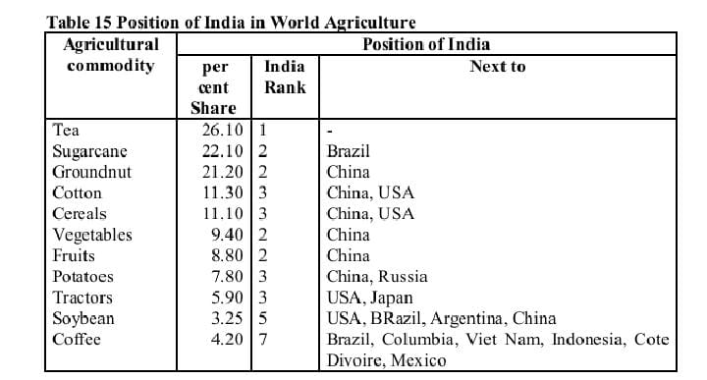

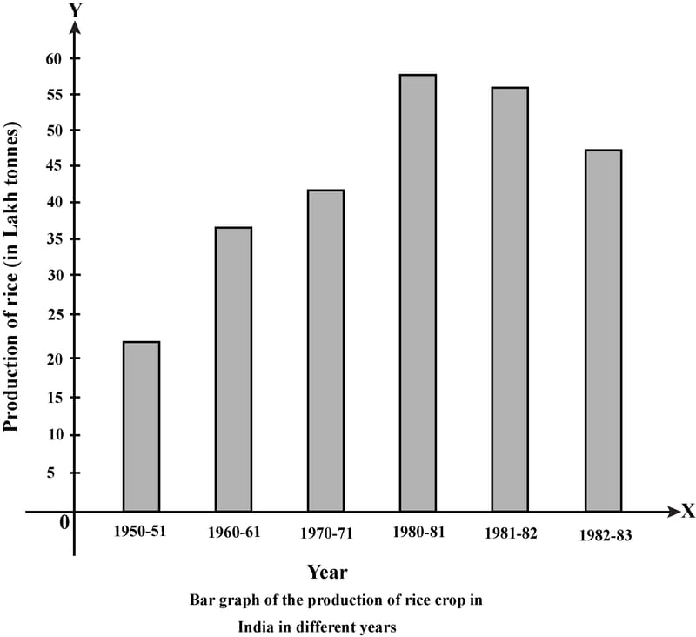

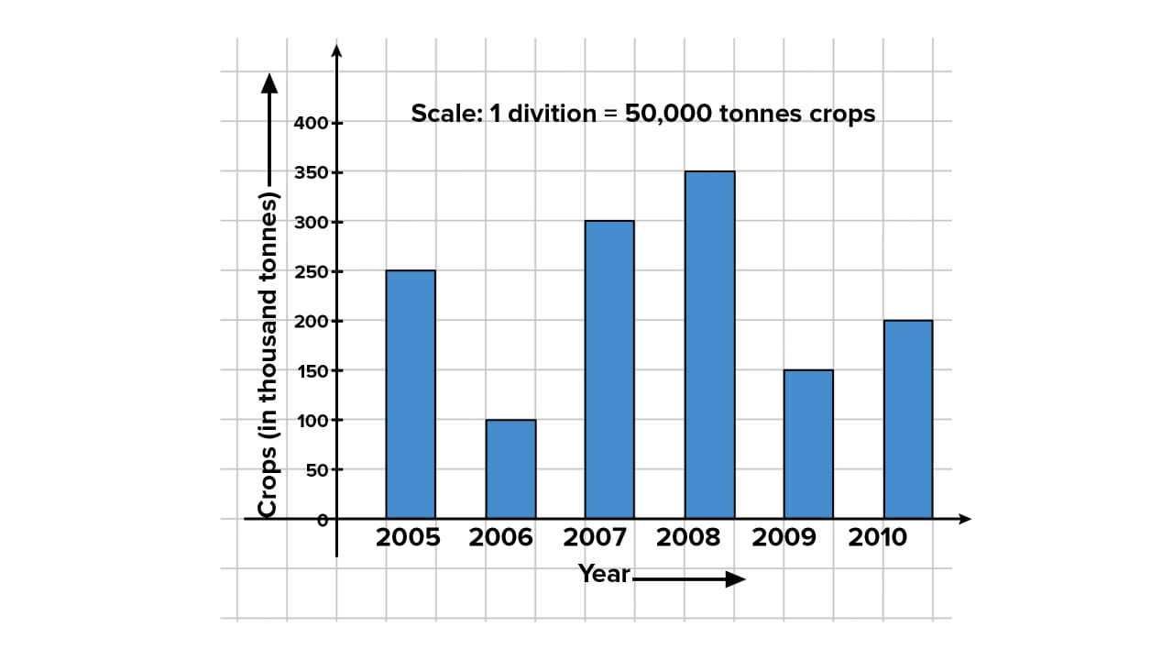

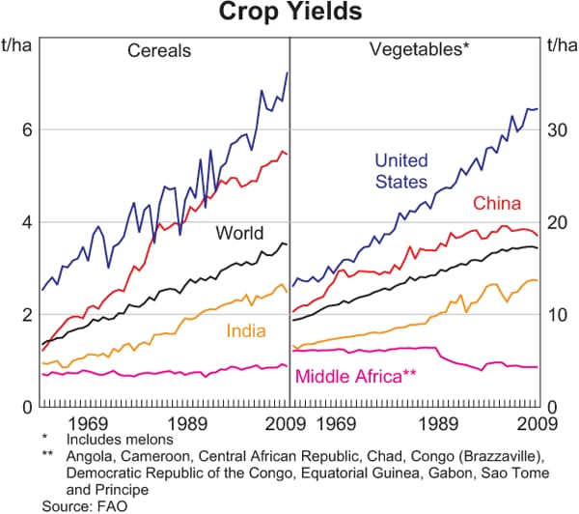

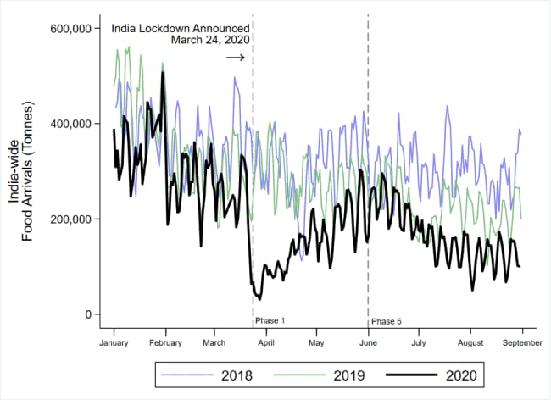

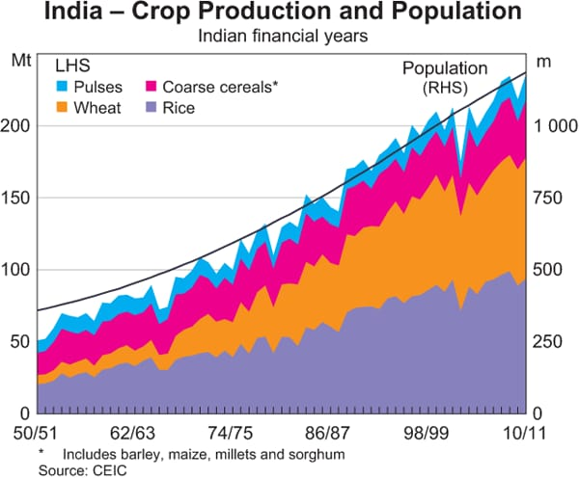

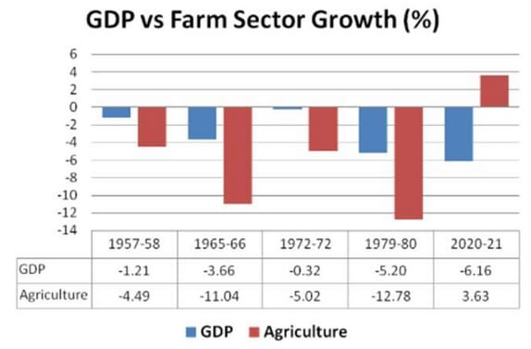

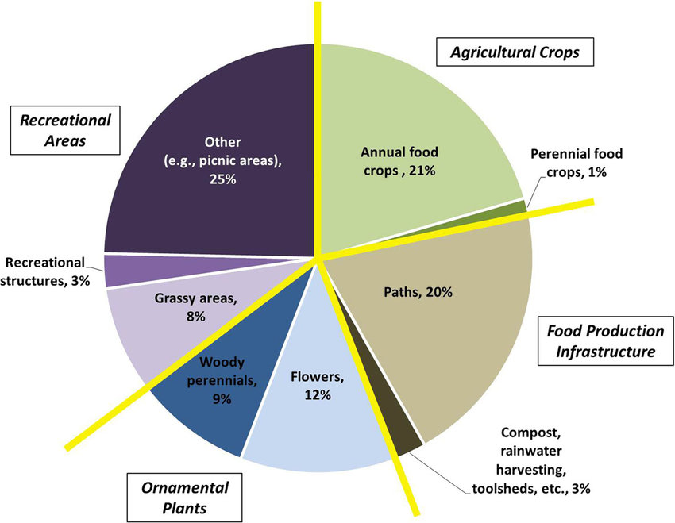

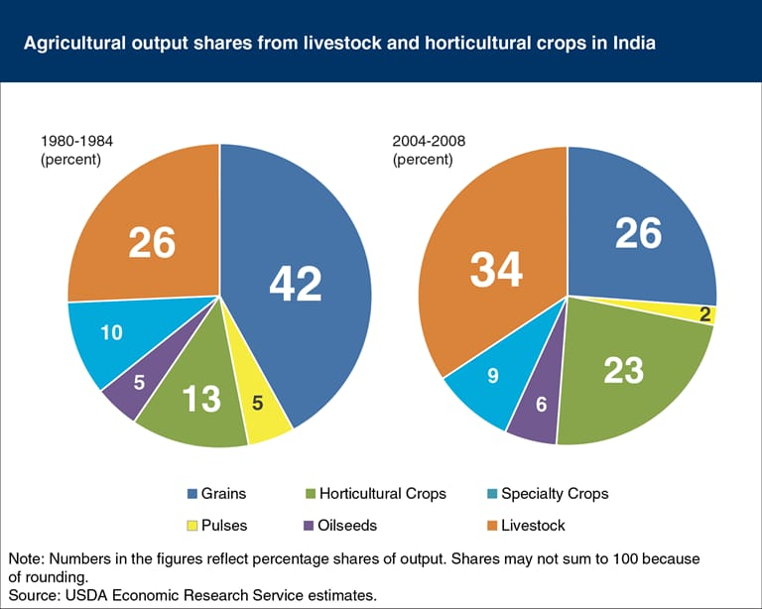

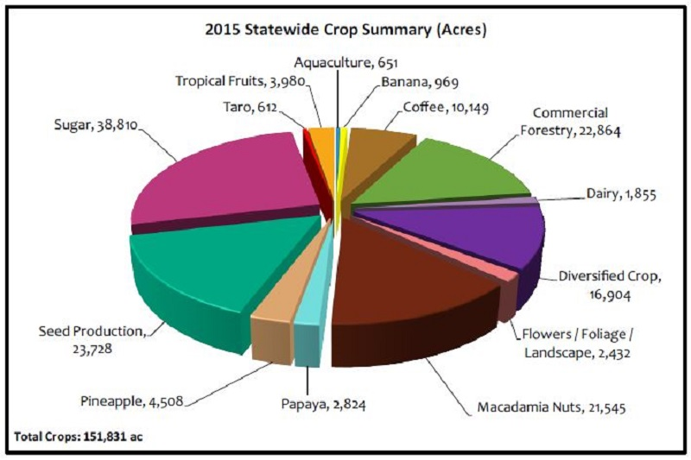

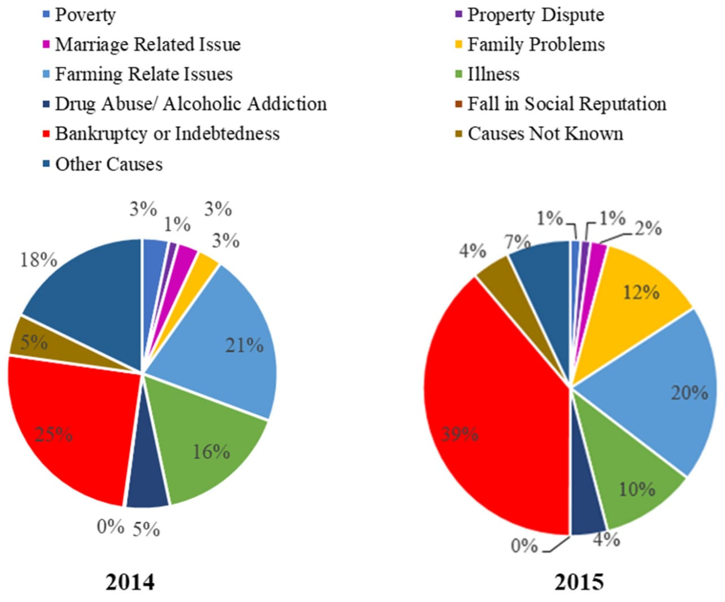

# **DATA VISUALIZATIONS**

**DASHBOARD**

The country has made significant progress in the adoption of modern methods of

cultivation and creating infrastructure for effectively and sustainably utilizing the

national resources available at its command. It has transformed its image from that of

a ‘begging bowl’ to bread basket due to the efforts of various agencies combined with

scientific and engineering inputs in agriculture. Indian agriculture has evolved into a

mature and modern enterprise over the last five decades. Farm mechanization has

reached a level of maturity pushing the net sales of machinery to over Rs 50,000

crore, almost entirely through indigenous efforts. Farm mechanization programmes

pursued in the country after attaining independence were directed towards optimal

utilization of available farm power sources. The impact of tractorization as against

oxenisation is evident from the fact that India is the largest producer of tractors in the

world. Increase in cropping intensity, timeliness of operations and reduction in

drudgery have been shown to be the needed incentives for farmers and farm workers

to adopt modern methods of cultivation. An increase of 15 per cent in productivity

and a reduction of 20 per cent in the cost of cultivation can be achieved by

engineering interventions. These interventions have been limited to a few field crops,

farm operations and post harvest activities. There is an urgent need to extend it to the

entire gamut of production agriculture in the country.

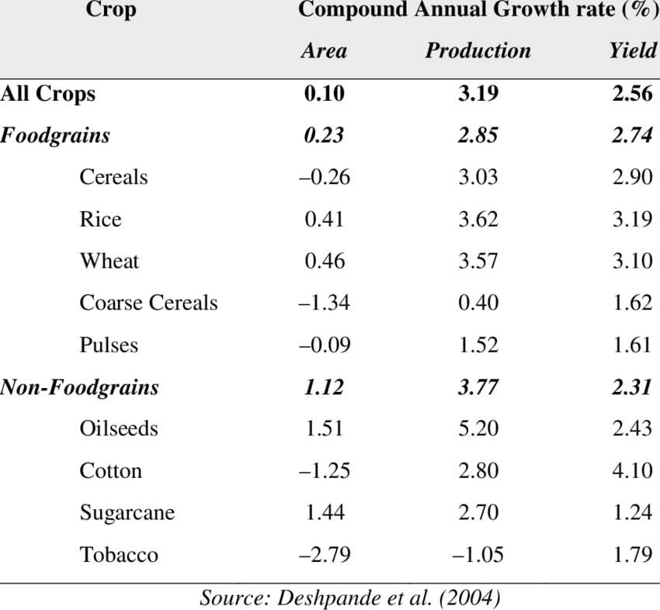

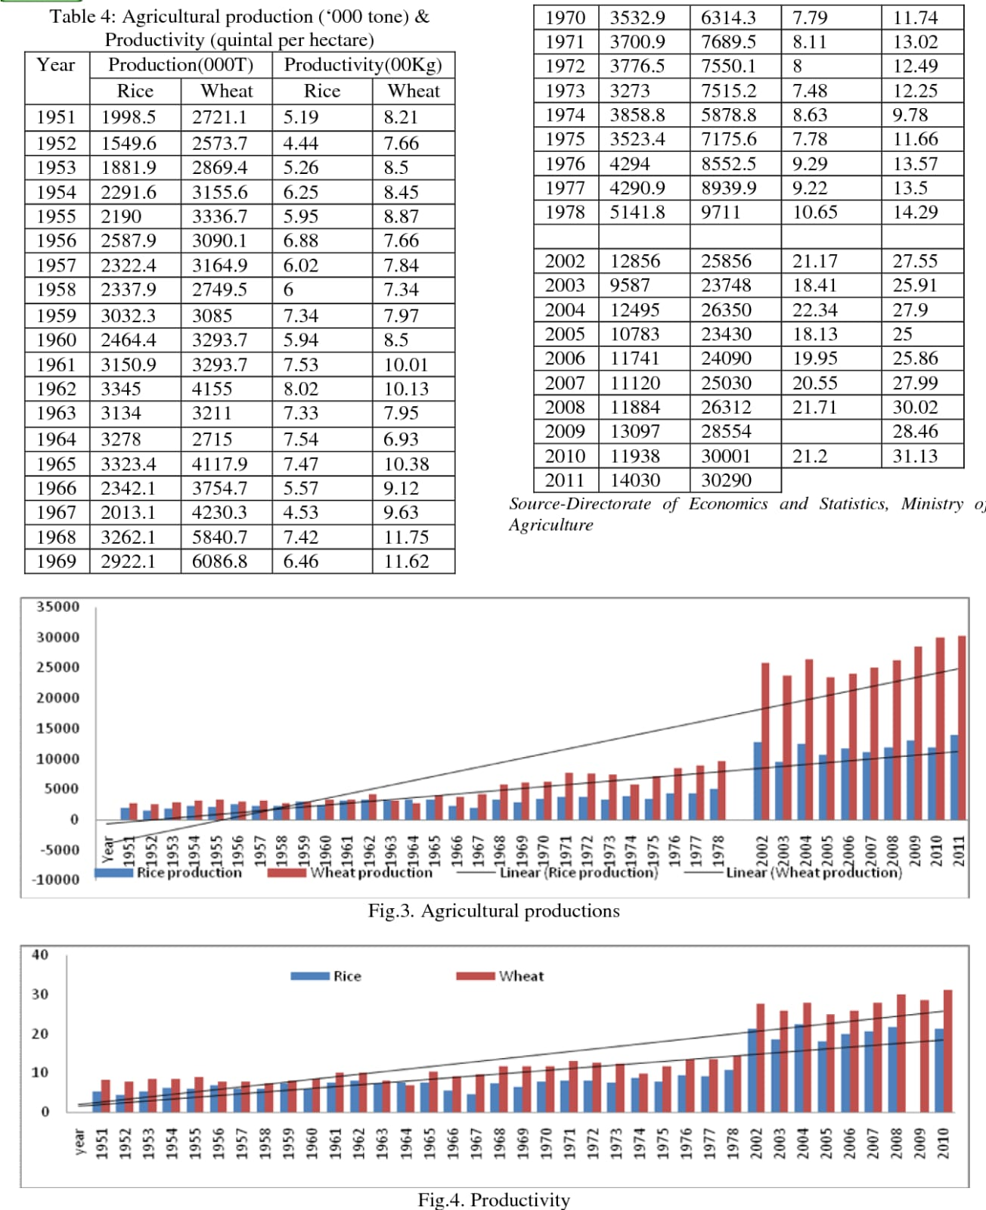



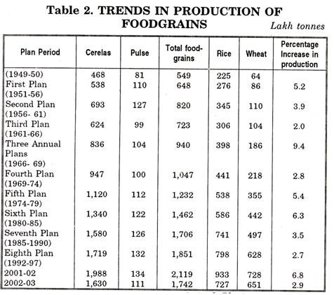

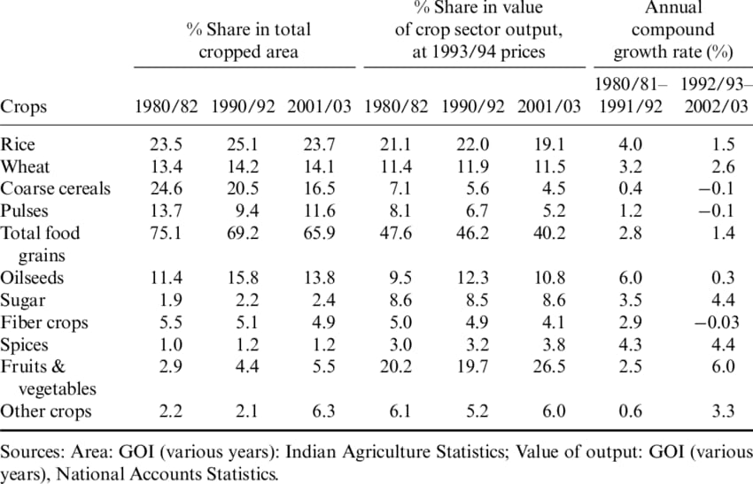

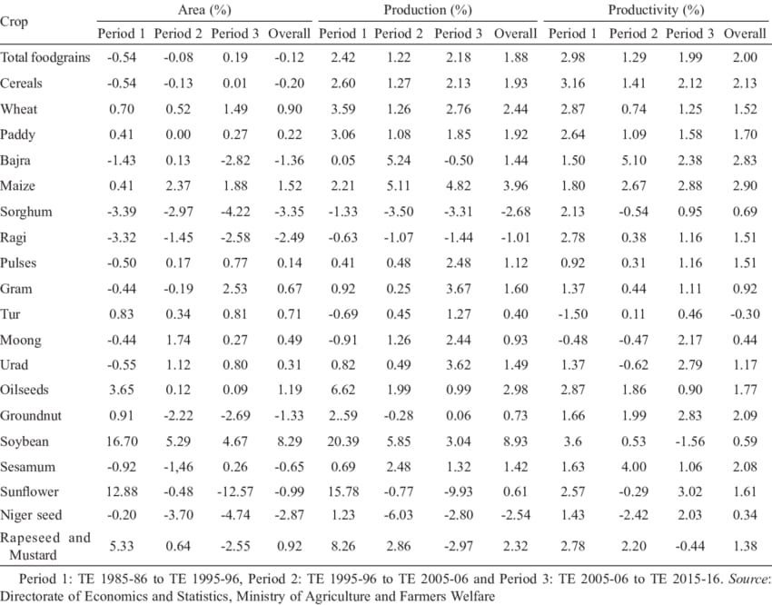

Post harvest characteristics of agricultural produce is affected by pre-harvest

treatments-seed rates, level of fertilizer use, nutritional balance, irrigation and

drainage, attack f diseases and pests, growth hormones and pesticides used and their

residual toxicity, mechanical and environmental injuries during harvesting, handling ETC.

# **STORY**

For Indian farmer Buddha Singh, who works a small plot of land in the village of Bajna south of New Delhi, the government's decision to abolish 500 and 1,000 rupee bank notes to crush the shadow economy could hardly have come at a worse time.

He and millions of other farmers cannot get enough cash to buy the seeds and fertilisers they need for their winter crops, threatening production of key commodities and hurting rural communities only just recovering after two years of drought.

‘’We can't buy our full requirements of seeds, fertiliser and pesticides on credit. There is a limit," said Singh, a turbaned man in his 50s, who tills a two-acre field near the highway running from the capital to the holy city of Mathura.

"We're running out of time as we've only 10-15 days more to plant crops like wheat, mustard and chickpeas," he added, to murmurs of assent from around 30 fellow farmers sitting under a neem tree and discussing their predicament.

The breakdown in the cash economy is causing major disruptions to the supply of produce to India's cities, with payment alternatives such as plastic cards or digital wallet apps on smartphones yet to gain widespread acceptance.

At Delhi's Azadpur Mandi, Asia's largest fruit and vegetable wholesale market, traders said business was at a virtual standstill, and labourers who usually earn between $4 and $6 a day sat idle.

The bosses are giving us 500 rupee bills, but we are refusing to take those notes," said porter Raju Kumar Rathore. "Then they are telling us to collect our money after a week or 10 days. For us that is a big problem."

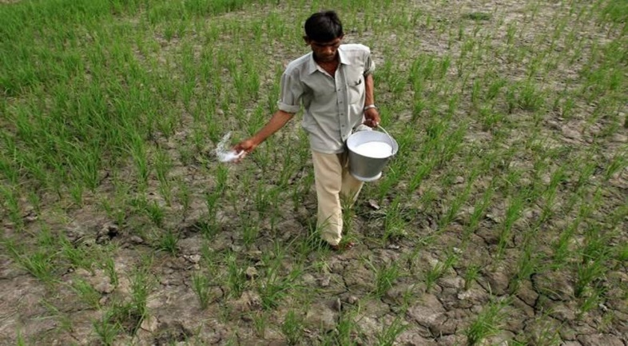

**MAJOR PROBLEMS FACED BY INDIAN FARMERS IN AGRICULTURE**

* Small and Fragmented land holdings
* Lack of Marketing and Storage facilities
* Poor Adoption of Mechanization
* Credit Availability
* Poor irrigation facilities
* Soil fertility depletion
* Inadequate access to crop insurance schemes
* Impact of climate change
* Price volatility
* Poor training and extension facilities
* Limited spending on R&D by Government

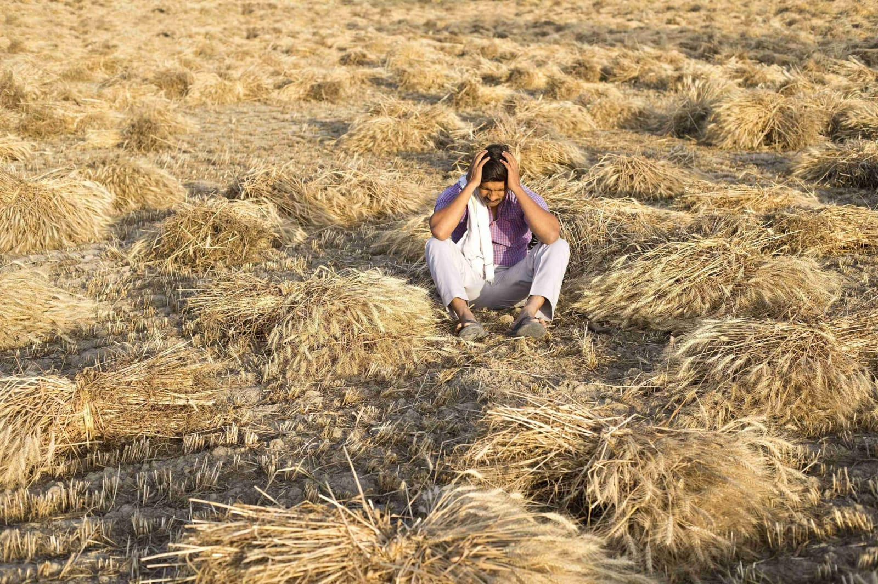

# **PERFORMANCE TESTING**

Agriculture is the main occupation of the Indian peoples. Performance of Indian economy is dependent upon the growth of Agriculture sector. It contributes nearly 16% of India’s Gross Domestic Product (GDP) & 13% of total exports. It provides employment to 52% of the country’s work force and livelihood security to more than 620 million people. Agriculture plays an important role in economic development, such as provision of food to the nation, enlarging exports, transfer of manpower to non-agricultural sectors, contribution to capital formation, and securing markets for industrialization. Agriculture forms the backbone of Indian economy and even though large industrialization in last 60 years, agriculture still occupies a place of pleasure.

Performance of Indian economy is dependent upon the growth of Agriculture sector. It contributes nearly 16% of India's Gross Domestic Product (GDP) & 13% of total exports. It provides employment to 52% of the country's work force and livelihood security to more than 620 million people.

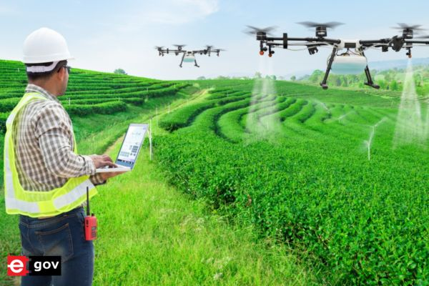

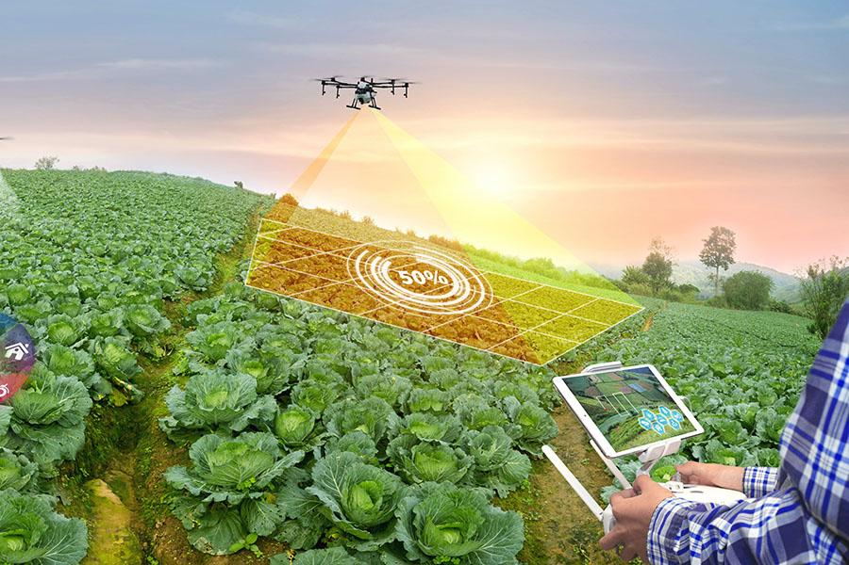

# **WEB INTEGRATION**

ICT-based interventions such as smart farming and precision agriculture are helping to improve the output of traditional agricultural systems and drive them toward sustainability. Data-driven technologies like remote sensing, smart sensors, and IoT-based devices constructed over AI/ML algorithms have become a fundamental aspect of agriculture that assists farmers with critical decision-making. This revolution is strengthening the farmers in terms of farm management by improving crop yield, pest control, soil health, etc. in real-time. We have thoroughly reviewed the digital adoption in terms of insights into the Indian agriculture sector and presented a comprehensive account of major ICT initiatives undertaken followed by a redundancy analysis as well as its influence on the sector. Unfortunately, while being a significant agrarian country, India's adoption of digital solutions is still in its infancy, as apparent from a close look at important FMIS and key components of recognized solutions used internationally. We found 28 FMIS solutions that are active globally, and have produced a list of 29 local (Indian) applications spread across 23 different agricultural sub-domains. Sadly, a majority among these were not unique and replicated similar features, besides just a few were found to be crop-specific applications. The article is unique in its approach to presenting the tale of digital penetration in the Indian agriculture sector and will be helpful to further Agri-stack vision of India.

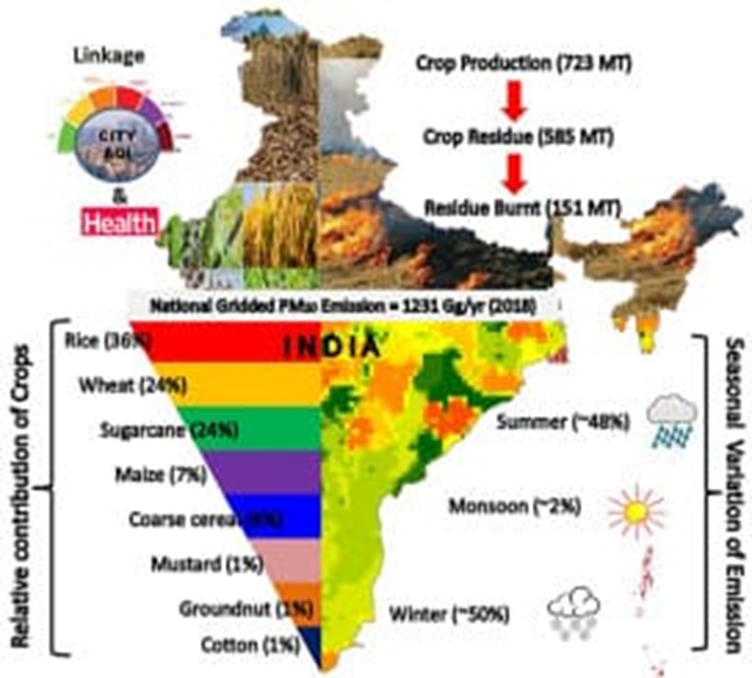

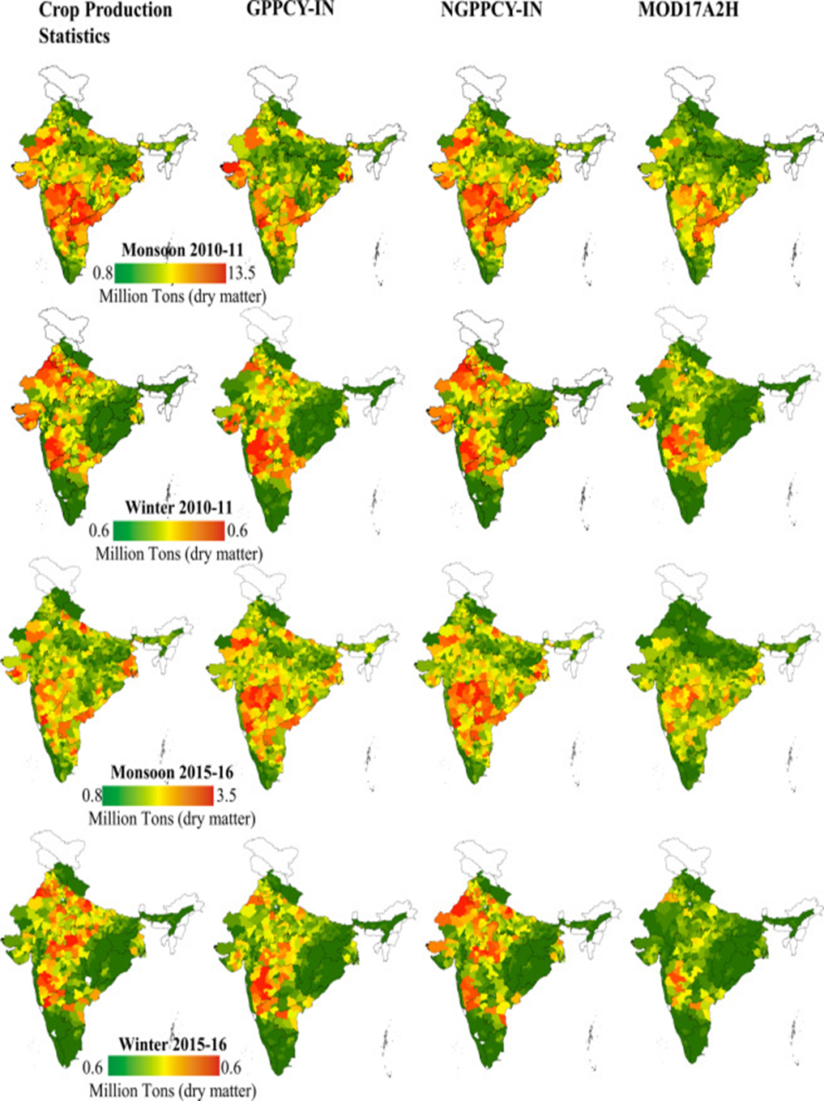

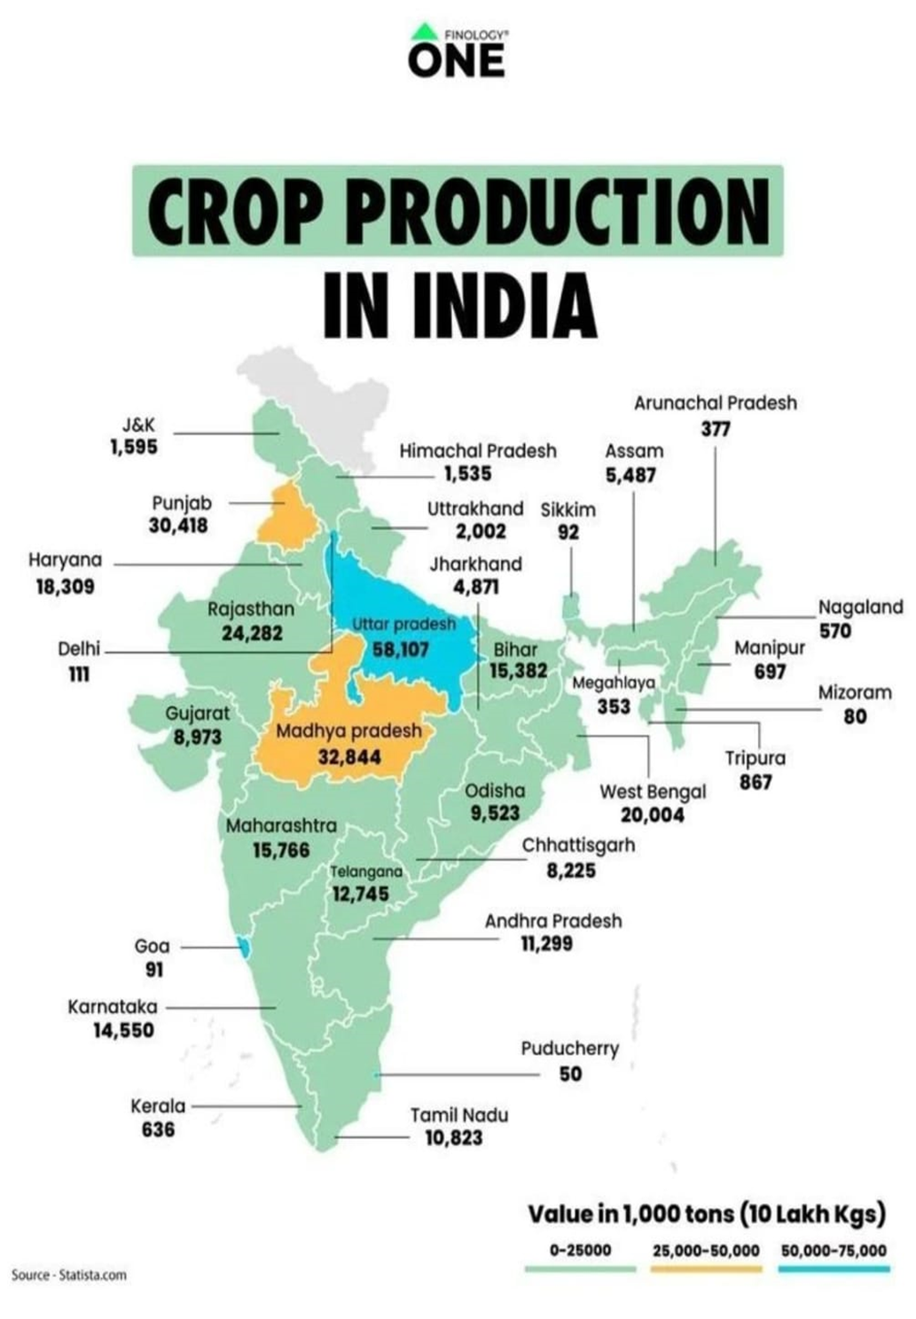

# **CONCLUSION**

The country has made significant progress in the adoption of modern methods of cultivation and creating infrastructure for effectively and sustainably utilizing the national resources available at its command. It has transformed its image from that of a ‘begging bowl’ to bread basket due to the efforts of various agencies combined with scientific and engineering inputs in agriculture. Indian agriculture has evolved into a mature and modern enterprise over the last five decades.

Farm mechanization has reached a level of maturity pushing the net sales of machinery to over Rs 50,000 crore, almost entirely through indigenous efforts. Farm mechanization programmes pursued in the country after attaining independence were directed towards optimal utilization of available farm power sources. The impact of tractorization as against oxenisation is evident from the fact that India is the largest producer of tractors in the world. Increase in cropping intensity, timeliness of operations and reduction in drudgery have been shown to be the needed incentives for farmers and farm workers to adopt modern methods of cultivation. An increase of 15 per cent in productivity and a reduction of 20 per cent in the cost of cultivation can be achieved by engineering interventions. These interventions have been limited to a few field crops, farm operations and post harvest activities. There is an urgent need to extend it to the entire gamut of production agriculture in the country.The Country has an extensive research and development system for farm machinery design and development for production agriculture, post harvest, and utilization of renewable sources of energy covering various zones and agro-climatic regions.

Extensive facilities for the testing of farm equipment and machinery including different kinds of prime movers is also a part of the agricultural equipment development network in the country which meets not only the national requirements but is also available for neighbouring countries.

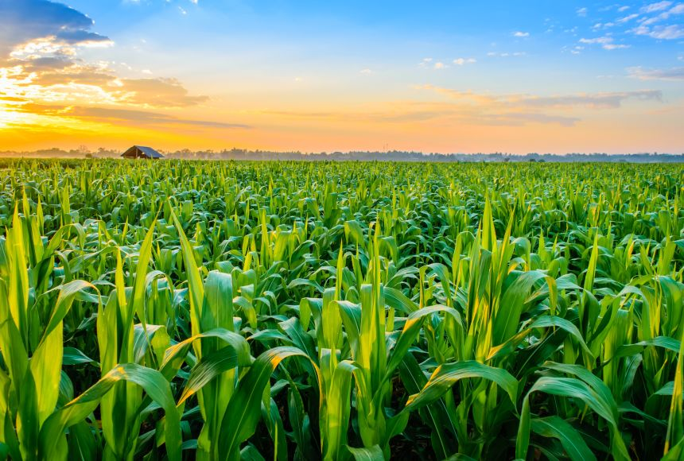

BY-

SWATHI , RENUKA , SAMYUKTHA , KIRAN